Program Challenge Worksheet #3

Determine 1-2 actions you can implement to overcome personal barriers and reach your healthy lifestyle goals.

1.
2.

SMART goals are designed to focus your efforts and increase the chances of achieving your goals. Use these templates to start building out your exercise and lifestyle physical activity goals.
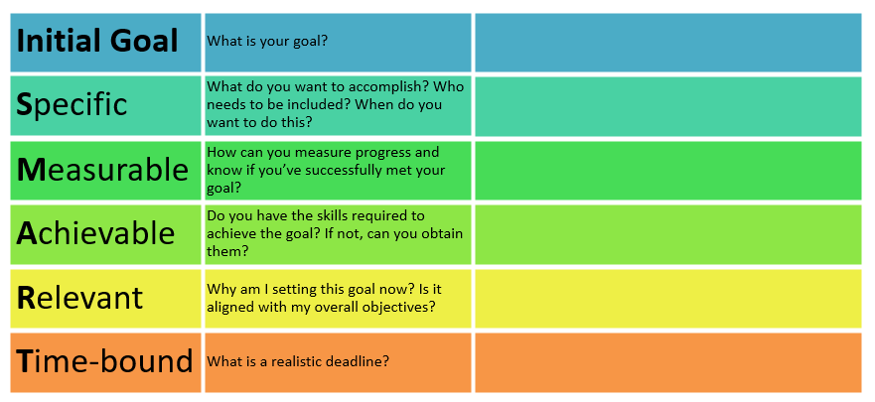

To help you stay committed to your wellness goals, we encourage you to complete this
Wellness Commitment Pledge.

I commit to increasing my movement by adding the
(name)

following exercise/lifestyle physical activity for
(type of activity) (total minutes)

minutes per day, at least times per week. My accountability and
(total days per week)

support contact will be .
(name of individual)

