Program Challenge Worksheet #2

Exercising regularly and staying active through lifestyle physical activity can help you manage symptoms of MS. Identify the benefits of exercise and lifestyle physical activity you are most looking forward to and rank your top three below.

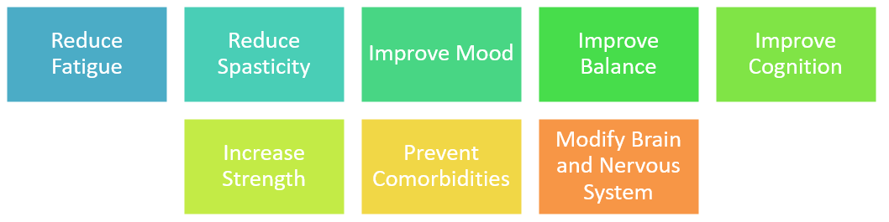

1.
2.
3.

For those living with MS at all ability levels, research suggests movement goals of 150 minutes per week or 30 minutes a day 5 days a week are beneficial. Think about where you are at right now. Identify exercise and lifestyle physical activities you are interested in increasing to bring you closer to this wellness goal.

Exercise/Lifestyle Physical Activity (type of movement and duration):

Exercise/Lifestyle Physical Activity (type of movement and duration):

Exercise/Lifestyle Physical Activity (type of movement and duration):

Exercise/Lifestyle Physical Activity (type of movement and duration):

Having a support system can help you reach your lifestyle physical activity and exercise goals. Identify an accountability partner. This could be a family member, friend, colleague, or self-help group leader.

My accountability partners is:____________________________________________________________

