Program Challenge Worksheet #1

It is important to track your perception of your wellness status and learn how to manage changes and develop healthy lifestyle behaviors. Place an X where you rank yourself in the following wellness dimensions.

Physical Wellness
Unwell Neutral Well

Emotional Wellness
Unwell Neutral Well

Occupational Wellness
Unwell Neutral Well

Spiritual Wellness
Unwell Neutral Well

Social Wellness
Unwell Neutral Well

Intellectual Wellness
Unwell Neutral Well

Several factors contribute to personal wellness. Think about those that play a role, positive or negative, in your personal wellness.

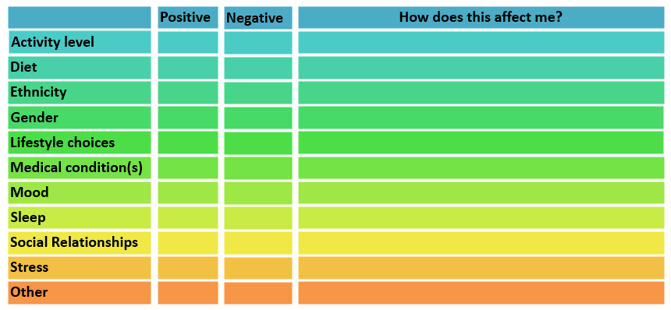

Choose 1-2 strategies that you can focus during this program series, that can help move you closer to “well” on any of the dimension of wellness.

Strategy #1:

Strategy #2:

